**Assignment 1- Fundamental of Database Systems**

**Name: Talha Abdullah Punjabi QUID: 201903446**

1. [2 pts] A database is needed for home delivery from a furniture store such as IKEA, where delivery employees take orders for items from customers. The data requirements are summarized as follows:

• The store has employees, each identified by a unique employee number, first and last name, and phone number.

• Each customer of the store is identified by a unique customer number, first and last name, and a phone number.

• Each item sold by the store is identified by a unique item number, an itemname, price, and quantity in stock.

• Each order placed by a customer is taken by an employee and is given a unique order number. Each order contains specified quantities of one or more items. Each order has a date of receipt as well as an expected ship date. The actual ship date is also recorded.

Design an entity–relationship diagram for the mail order database.

Ans) 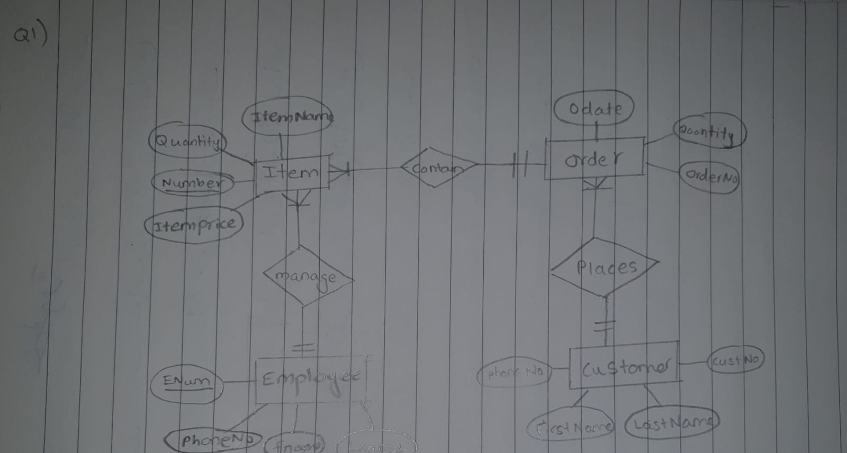

Ans)

1. Strong entity – Flight, Airport, Airplane, Airplane-Type
2. Weak entity – Fare, seg_instance, flight_seg, seat

Partial keys- date, code, seat_no, flight_seg_no

1. The constraint is the referential integrity as the foreign key is the identifying one, for all weak entities.
2. Relations
3. Can-Land – (M-N) to Type (1-N)
4. Arrives – (1-N) to fares (1-N)
5. Assigned –(1-N) to departs (1-N)
6. Take off Airport (1-350)
7. Legs – (15-1) to Landing Airport (1-350)

Ans) 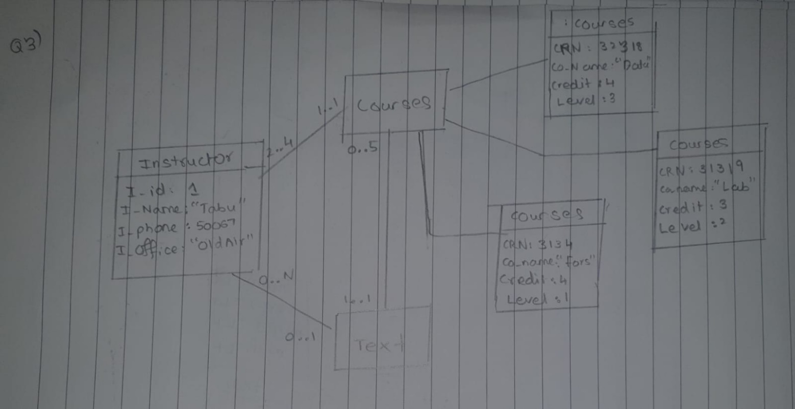

Ans)

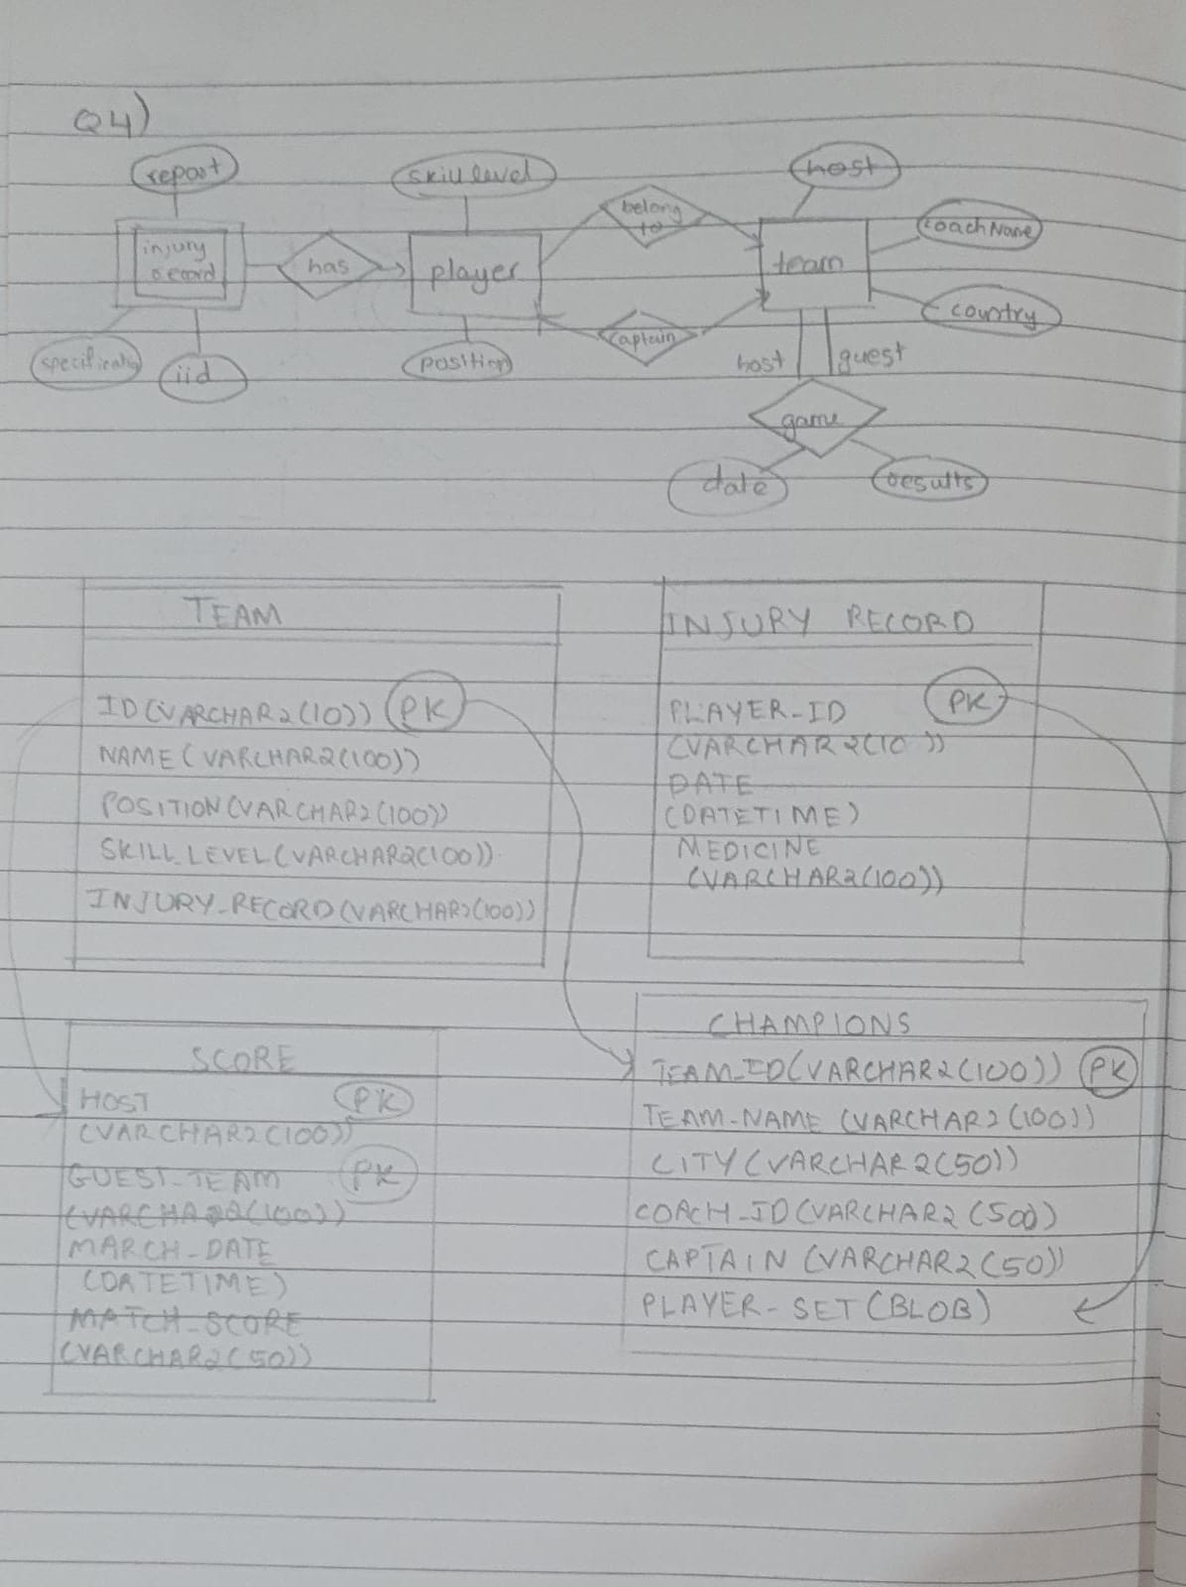

Ans)